TOWN OF ISLE LA MOTTE
INVITATION TO BID: MUNICIPAL GROUNDS LAWN CARE

The Town of Isle La Motte (the "Town") is currently accepting bids lawn care of the Municipal lands as detailed in the following scope of work

There are three separate bidding categories detailed.

Category #1 – Town lands ONLY mowing and lawn care

Category #2 – Town Cemeteries ONLY mowing and lawn care

Category #3 – BOTH town lands and Town Cemetery mowing and lawn care

Please Break down the Bid for EACH of the THREE following categories: (Selectboard may choose to award the bid for one section or both sections at their sole discretion)

• Category one: Town owned lands are as follows:
- #1 - The Isle La Motte Town Office (previously the Elementary School)
- #2 -Rec. Park / Salt Shed Area
- #3 -Old Town office
- #4 -Monument at Burying Yard Point at the bridge.
- #5 -Monument on Shrine Rd.
- Lawn care at the Town Offices includes:
  - mowing and trimming of the lawn, around the playground
  - the edges of the driveway up to the road
  - around the sign at the top of the driveway and
  - the leach field in the back of the building as needed.
- Lawn care at the Rec, Park / Salt Shed included:
  - mowing and trimming the lawn, around the playground
  - around the pickleball court
  - to the edge of the road
  - around the port-o-let
- Lawn care at the old Town Hall includes:
  - mowing and trimming around the building.
- Lawn care at Burying Yard Point includes:
  - mowing and trimming around the monument to the edge of the road on the north, the edge of the lake on the east and to the tree line on the south and west.
- Lawn care at the Monument on Shrine Road includes:
  - mowing and trimming around the monument

• Category two: Cemeteries to include:
- #6 - Bruley Rd. Cemetery
- #7 - School St. Cemetery
  - Contractor must have the appropriate equipment to complete the work so as not to disturb headstones, memorials or any aspect of the cemeteries.
  - Clean up is generally performed mid-April, and mowing and trimming occurs through mid-October.
  - The contractor will be responsible for mowing, trimming, and general upkeep of both cemeteries, maintaining the grounds in a neat, safe and well cared manner.
  - Please include in your bid details on equipment owned, and detailed plans on how to mow our historic and sensitive plots.

• Category three: Both Municipal owned land and both cemeteries
- All details of category #1 and #2.

Project Requirements:

1. Contractor shall meet with the Selectboard [and the Cemetery Commission (Categories #2 and #3 only)] prior to start of work, and no later than five days after bid awarded
2. The Contractor shall be liable for any property damages which The Contractor causes.
3. Equipment breakdown experienced by The Contractor is the sole responsibility of The Contractor, and in no way shall it reflect a cost overrun.
4. The Contractor will not block town roads while performing duties or, if parked on the roadway, must provide and use flaggers and proper signage (e.g., two “Road Work Ahead” signs) to conform to State of VT standards.
5. The contractor shall be responsible for leaving the town grounds and cemeteries (Categories #2 and #3 only) in a neat and orderly condition at the end of each workday.
6. Contractor shall mow grass, so clippings stay within the property or yard.
7. Contractor shall use mowing attachments or techniques that direct clippings away from public roads and bodies of water.
8. Contractor shall clean up any grass clippings that inadvertently reach the street immediately after mowing.
9. Contractor shall adhere to proper mowing practices to protect other road users and the ecology of the lake waters
10. Contractor must maintain regular and open communications with town officials.

Contract Requirements:

1. Contract will be signed by the Selectboard [and the Cemetery Commission (Categories #2 and #3 only)] before work starts.
2. In the event this contract is not adhered to, The Town will have the option to terminate said contract with a fourteen (14) day notice to The Contractor.

Bids form and proof of insurance must be sealed and received at the Town Office located at 42 School St. Ext Isle La Motte, VT 05463 or mailed to P.O Box 250 Isle La Motte, VT 05463 by April 14th, 2026 at 4:00 pm. Please write: “Attn: Mowing Bid , and due DATE” on the front of the envelope. A signed contract IS required.

Bids will be opened at the Select Board Meeting on April 15th, 2026. Any questions (including project maps) regarding this bid please contact Cary Sandvig at csandvig@islelamotte.gov

The Town of Isle La Motte reserves the right to accept or reject all bids.

A Bidders meeting will be held on April 1st, 2026 at

Other Requirements:

Bid Requirements:
All bids must be submitted in sealed envelopes, addressed to the Town in care of the Selectboard, and plainly marked with the name of the bid and the time of the bid opening. Bid proposals will be date stamped on the outside of the envelope immediately upon receipt. Any bid may be withdrawn in writing prior to the scheduled time for the opening of bids. Any bids received after the time and date specified shall not be considered and shall be returned to the bidder unopened.

Bidders shall bid to specifications, and any exceptions must be noted by the bidder. A bidder submitting a bid thereby certifies that the bid is made in good faith without fraud, collusion, or connection of any kind with any other bidder for the same work, and that the bidder is competing solely on his/her behalf without connection with or obligation to any undisclosed person or firm.

1. The Contractor will mow at a frequency of once per week or as needed at each location. Contractor to use best judgment for each location to best keep the grounds presentable, safe and clean.
2. The bid must include cost estimates for the category being bid on by the contractor.
3. The Contractor must include five copies of the bid in the envelope.
4. A pre-bid meeting will be held on Monday, April 1st at 10:00am at the Isle La Motte Town Office. Interested parties are invited to attend, but attendance is NOT mandatory.
5. The Contractor must file a certificate of insurance stapled to the outside of the sealed bid envelope being submitted
6. Contractor must include a signed copy of the contract
7. If the bid is mailed, the sealed bid and insurance certificate must be placed within an addressed and stamped envelope. The sealed bid and insurance will be removed from the addressed envelope to check that the insurance was included and date stamped.

Payment:

Assuming timely and successful completion of work tasks as specified above, all payments will be made within thirty (30) days of submission of the applicable invoice.

Bid Submission Details:

Bid form and proof of insurance must be sealed and received at the Town Office located at 42 School St. Ext. Isle La Motte, Vt. 05463 or mailed to P.O. Box 250 Isle La Motte, Vt. 05463 by April 14th, 2026 at 4:00 pm. Please write: “Attn: Lawn Mowing Bids on the front of the envelope. A signed contract will be required for the bid to be considered.

Bids will be opened at the Select Board Meeting on April 15th, 2026. Any questions (including project maps) regarding this bid please contact Isle La Motte Selectboard Chair, Cary Sandvig at csandvig@islelamotte.gov

The Selectboard reserves the right at its sole discretion to reject any and all bids, wholly or in part, to waive any informalities or any irregularities therein, to accept any bid even though it may not be the lowest bid, to call for rebids, to negotiate with any bidder, and to make an award which in its sole and absolute judgment will best serve the Town’s interest. The Selectboard reserves the right to investigate the financial condition of any bidder to determine his or her ability to assure service throughout the term of the contract.

Bid Submission Checklist:
• Bid Form
• Bid name (on outside of the bid envelope)
• Bid submission deadline (on outside of the bid envelope)
• Date, location, and time of bid opening
• Five copies of the bid documents
• Bond and/or insurance requirements.
• A signed contract.
• List of equipment and methods to be used at the cemeteries (categories #2 and #3 only.

Bid Selection Criteria:
• Price
• Bidder’s ability to perform with the appropriate equipment.
• Bidder’s experience and reputation, including past performance for the Town
• Quality of the materials and services specified in the bid
• Bidder’s ability to meet other terms and conditions, including insurance and bond requirements
• Bidder’s financial responsibility
• Bidder’s availability to provide future service, maintenance, and support
• Nature and size of bidder
• Contract provisions that are acceptable to the Town
• Any other factors that the Selectboard determines are relevant and appropriate in connection with a given project or service.

MOWING BID FORM

Name/Company: ______________________________________________________________
Address: ______________________________________________________________
Phone Number: ______________________________________________________________
Email: ____________________________________________________________________

Category One:

Detail of work________________________________________________________________________
____________________________________________________________________________________
____________________________________________________________________________________
____________________________________________________________________________________

Category One: Total Cost ____________________

Category Two:

Detail of work________________________________________________________________________
____________________________________________________________________________________
____________________________________________________________________________________
____________________________________________________________________________________

Category Two: Total Cost ____________________

Category Three:

Detail of work________________________________________________________________________
____________________________________________________________________________________
____________________________________________________________________________________
____________________________________________________________________________________

Category Three: Total Cost ____________________

Completion Date: a frequency of once per week or as needed at each location. Contractor to use best judgment for each location to best keep the grounds presentable, safe and clean.

Describe the equipment you propose to use for the contract (categories #2 and #3 only):
_______________________________________________________________________________
_______________________________________________________________________________
_______________________________________________________________________________
_______________________________________________________________________________
_______________________________________________________________________________

Please describe any deviations from the bid specifications that you will need to follow or would suggest to the Town:

_______________________________________________________________________________
_______________________________________________________________________________
_______________________________________________________________________________
_______________________________________________________________________________

Signature of Bidder: __________________________________
Date: __________________________________

PROJECT MAPS

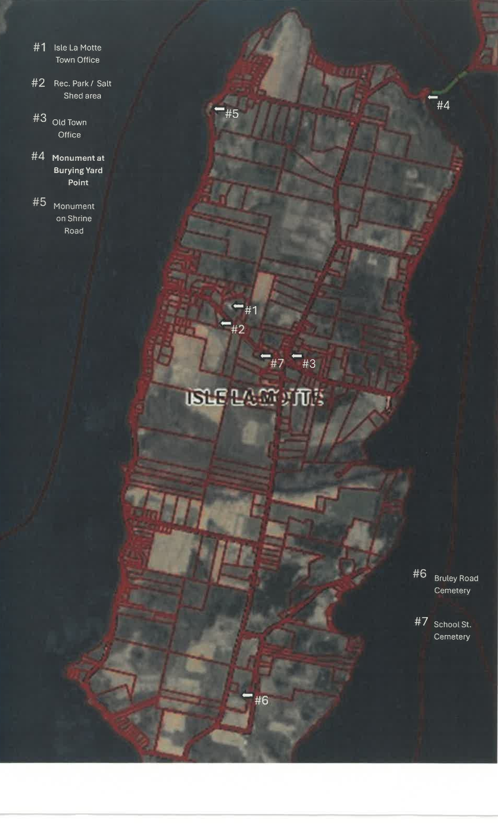

#5

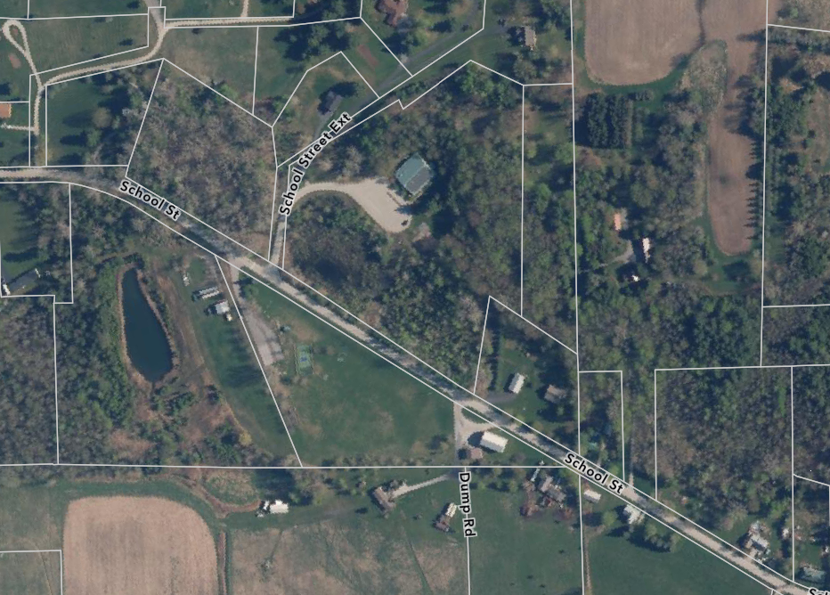

#1 Isle La Motte Town Offices

#2 Rec. Park & Salt Shed area

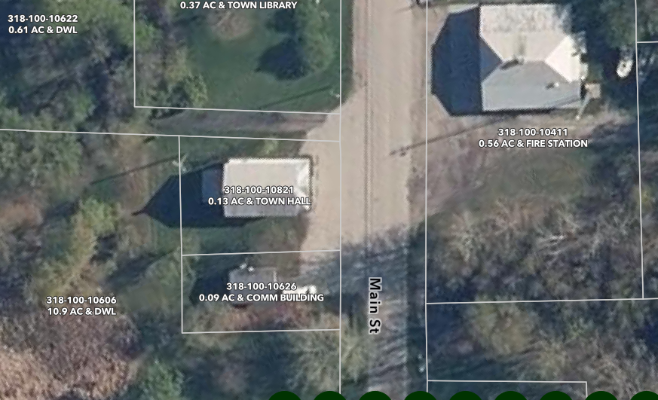

#3 Old Town Hall on Main Street

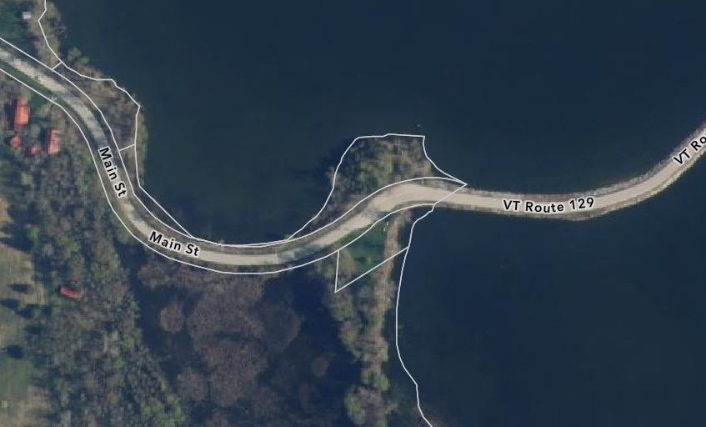

#4 Monument at Burying Yard Point

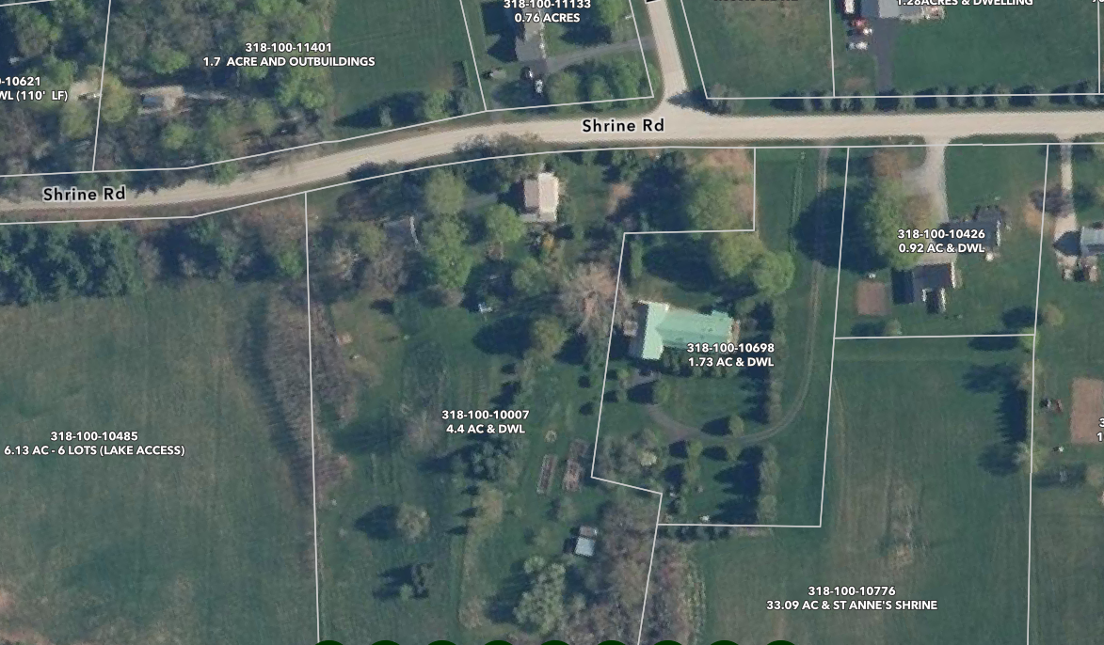

#4 Monument on Shrine Road

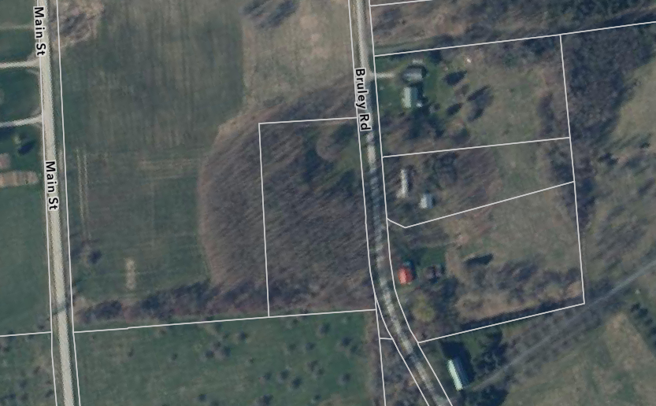

#6 Bruley Road Cemetery

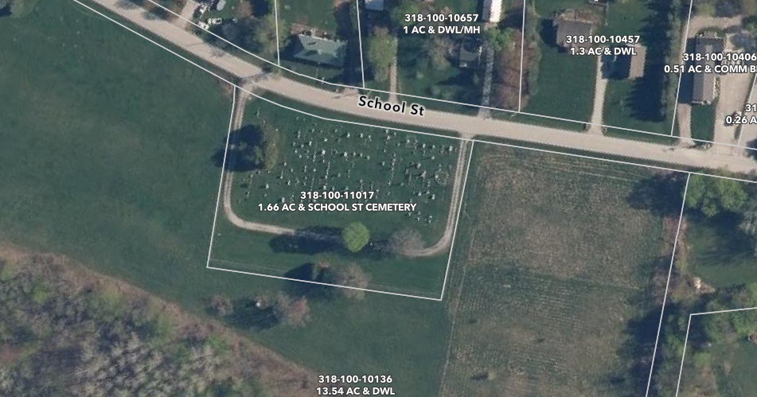

#7 School Street Cemetery

