Town of Isle La Motte
CONTRACT FOR LIMITED SERVICES

This Contract is entered into on this ___ day of _________, 2026, by and between the Town of Isle La Motte (hereinafter “Municipality”) and _____________________[Contractor Name], a________________________ [type of entity such as “limited liability corporation”] with a principal place of business in ______________, Vermont, with a mailing address of _________________________________, (hereinafter “Contractor”) for services to Municipality. Municipality and Contractor are referred to collectively as “parties.”
In consideration of the mutual covenants and agreements as hereinafter set forth, the parties hereto agree as follows:
ARTICLE 1: SERVICES PROVIDED
Contractor agrees to perform the following service(s) according to the following timelines or schedule:
Category #1: Mowing and lawncare at the following locations:
- #1 - The Isle La Motte Town Office
- #2 -Rec. Park / Salt Shed Area
- #3 -Old Town office
- #4 -Monument at Burying Yard Point at the bridge.
- #5 -Monument on Shrine Rd.
- Lawn care at the Town Offices includes:
  - mowing and trimming of the lawn, around the playground
  - the edges of the driveway up to the road
  - around the sign at the top of the driveway and
  - the leach field in the back of the build, monthly or as needed
- Lawn care at the Rec, Park / Salt Shed included:
  - mowing and trimming the lawn, around the playground
  - around the pickleball court
  - to the edge of the road
  - around the port-o-let
- Lawn care at the old Town Hall includes:
  - mowing and trimming around the building.
- Lawn care at Burying Yard Point includes:
  - mowing and trimming around the monument to the edge of the road on the north, the edge of the lake on the east and to the tree line on the south and west.
- Lawn care at the Monument on Shrine Road includes:
  - mowing and trimming around the monument

• Category #2: Cemeteries to include:
- #6 - Bruley Rd. Cemetery
- #7 - School St. Cemetery
  - Contractor must have the appropriate equipment to complete the work so as not to disturb headstones, memorials or any aspect of the cemeteries.
  - Clean up is generally performed mid-April, and mowing and trimming occurs through mid-October.
  - The contractor will be responsible for mowing, trimming, and general upkeep of both cemeteries, maintaining the grounds in a neat, safe and well cared manner.
  - Please include in your bid details on equipment owned, and detailed plans on how to mow our historic and sensitive plots.

• Category #3: Both Municipal owned land and both cemeteries
- All details of category #1 and #2.

ARTICLE 2: COMPENSATION AND BILLING
Invoices and Billing:
a. Assuming timely and successful completion of work tasks as specified above, all payments will be made within thirty (30) days of submission of the applicable invoice.
b. Contractor shall submit invoices for completed work to the Municipality. Municipality shall pay Contractor’s invoices within 30 days of Contractor’s submission of an invoice. The maximum compensation (subject to additions or deductions provided herein) shall be in conformity with Contractor’s submitted Bid forms incorporated herein by reference.
ARTICLE 3: TERM
The term of this Contract shall be from ____________, 2026 to _____________, 2028. The term of the Contract may be extended only by mutual written agreement of the parties.
ARTICLE 4: INDEPENDENT CONTRACTOR
Contractor further acknowledges and agrees that it is an independent contractor and that nothing herein shall be construed to create the relationship of employer and employee between Municipality and Contractor. No employee-related withholdings or deductions shall be made from payments due Contractor. Contractor shall not be entitled to receive any benefits from Municipality and shall not be eligible for workers’ compensation or unemployment benefits.
ARTICLE 5: ASSIGNMENT AND SUBCONTRACTING
This Contract is binding upon and inures to the benefit of the heirs, successors, and assigns of the parties hereto. Neither party hereto may assign its rights or obligations under the Contract without the prior written consent of the other party. This Contract shall be governed by the laws of the State of Vermont.
Contractor shall not enter into any subcontract for performance of any services contemplated under this Contract nor assign any interest in the Contract without the prior written approval of Municipality and subject to such conditions and provisions as Municipality may deem necessary or desirable in its sole discretion. If Municipality permits the use of subcontractors, no subcontractor may perform any work under this Contract without first providing Municipality certificates of insurance showing all of the coverages required in Article 10 of this Contract. Contractor shall be responsible for the performance of all subcontractors. Before paying a claim that involves the use of materials or labor supplied by someone other than the Contractor, Municipality may require Contractor to supply proof of payment for such materials or labor. Contractor shall pay the subcontractor(s) for undisputed services provided by them within 30 days of receiving payment from Municipality.
ARTICLE 6: EQUIPMENT AND MATERIALS
Contractor warrants that it has the necessary equipment to provide the services required by this Contract. Contractor will be solely responsible for supplying, storing, maintaining, and replacing any and all equipment that is necessary for implementing the services under this Contract. Municipality will not supply, nor will it pay for any repairs, maintenance or replacement of, or new equipment expenses, or temporary work related to signs, cones, or other traffic controlling equipment.
ARTICLE 7: PERSONNEL
Contractor is responsible for compliance with all applicable State and Federal laws. Contractor will manage his/her own personnel without general oversight by the Municipality and shall oversee and coordinate sub-contractors that are approved by Municipality.
Contractor alone shall be responsible for ensuring compliance with all applicable regulatory requirements including but not limited to those from FMCSA and Vermont Occupational Safety and Health Administration (VOSHA).
Contractor further agrees to include this provision in all subcontracts.
ARTICLE 8: SAFETY AND TRAFFIC CONTROL
The Contractor alone shall be responsible for the safety and security at sites and when working in or adjacent to public highways.

ARTICLE 9: INDEMNIFICATION
Contractor shall indemnify, defend, save and hold harmless Municipality, and Municipality’s agents and employees, from and against all losses and all claims, demands, payments, suits, actions, recoveries, claims of outstanding indebtedness, attorneys’ fees, liens, and judgments of every nature and description, brought or recovered against them by reasons of any act or omission of the said Contractor, its agents, employees, or sub-contractors, in the execution of the work or in guarding the same. The Contractor shall defend the Municipality and its officers and employees against all claims or suits arising in whole or in part from any act or omission of the Contractor or of any agent or subcontractor of the Contractor. The Municipality shall notify the Contractor in the event of any such claim or suit, and the Contractor shall immediately retain counsel and otherwise provide a complete defense against the entire claim or suit.
Contractor shall assume full responsibility for the protection of all buildings, structures, and utilities (both public and private). All damage, injury, or loss to any public or private property, by the Contractor, or any sub-contractor, shall be replaced or restored to at least the original condition to the satisfaction of the Municipality at the Contractor’s expense.
Nothing in this Contract shall constitute a waiver by the Municipality of any statutory limits or immunities from liability.
ARTICLE 10: INSURANCE
Before commencing work on this Contract, the Contractor must provide certificates of insurance to show that the following minimum coverages are in effect. Contractor agrees that it will provide and maintain during the entire term of this Contract the following insurances with at least the indicated amounts of coverage and provide Municipality a certificate of insurance showing such coverages before providing any services under this Contract: (1) Commercial General Liability insurance coverage with a policy limit of at least $1,000,000 per occurrence and $2,000,000 in aggregate; (2) Business Automobile Liability coverage with total liability limits of at least $1,000,000; and (3) Statutory Workers’ Compensation insurance. If Contractor is not required by law to carry workers’ compensation insurance, in place of proof of workers’ compensation insurance Contractor may provide a fully executed Non-Employee Work Agreement specifying the particular provision of 21 V.S.A §601(14)(F) that exempts Contractor from having to carry such coverage.
The Contractors policies shall name the Municipality as an additional insured.
ARTICLE 11: WARRANTY AND BOND
a. Contractor shall post a performance and payment bond of 100% of the contract price within five (5) business days of being awarded this Contract.
b. Contractor warrants all work performed under this Contract for a period of one year from the date the work is completed and accepted by Municipality. The warranty must be secured by either Contractor’s performance bond or such other security as is acceptable to Municipality.
ARTICLE 12 NON-APPROPRIATION
If this Contract extends into more than one fiscal year of the Municipality and if appropriations are insufficient to support this Contract, the Municipality may cancel at the end of the fiscal year.
ARTICLE 13: TERMINATION
Municipality may terminate this Contract, with or without cause, upon 14 days written notice.
ARTICLE 14: DEFAULT
The occurrence of any of the following shall constitute default by Contractor and, if not corrected within 10 days of Municipality providing Contractor written notice of the default, shall allow Municipality to terminate this Contract:
1. failure to adequately perform or deliver the required services;
2. failure to provide the required bonds or other security acceptable to Municipality before starting any work;
3. declaration of bankruptcy by Contractor;
4. making a material misrepresentation to Municipality;
5. persistently disregarding laws, ordinances, rules, regulations, or orders of any public authority having jurisdiction; or
6. failure to perform any other material provision of this Contract.
7. Failure to answer requests from the Municipality for information and questions within five (5) business days.

Upon default of this Contract by Contractor, Municipality may withhold any payment due Contractor for purposes of set-off until such time as the exact amount of damages due is determined. Such withholding shall not constitute default or failure to perform on the part of Municipality.
Neither party shall be held responsible for delay or failure to perform when such delay or failure is due to any of the following uncontrollable circumstances unless the act or occurrence could have been foreseen and reasonable action could have been taken to prevent the delay or failure: fire, flood, epidemic, wars, acts of God, acts of public authorities; provided the non-performing party gives notice as soon as possible to the other party of the inability to perform. The Municipality and the Contractor agree to attempt to resolve quickly all matters related to uncontrollable circumstances and use all reasonable effort to mitigate its effects.
In addition to the above, in the event of a State or Federal Disaster Declaration, Municipality reserves the right to suspend certain provisions of this Contract to conform with Federal or Vermont Emergency Management regulations and directives.
Upon completion of the work or upon termination of the Contract, the Contractor shall remove from the vicinity of the work all equipment and all temporary structures, waste materials, and rubbish resulting from its operations, leaving the premises in a neat and presentable condition. In the event of failure to do so, the same may be done by the Municipality at the expense of the Contractor.
ARTICLE 15: REMEDIES
Default or breach of this contract by Contractor shall entitle Municipality to seek remedies under law and as provided by this Contract. In the event this Contract is terminated by reason of default by Contractor, Municipality may recover the necessary costs of termination, including but not limited to, administrative, attorneys’ fees and legal costs, from Contractor. Except when caused by uncontrollable circumstances, if Contractor fails to meet any performance deadlines established by this Contract, or fails to perform in accordance with the specification, terms, and conditions of this Contract, Municipality shall have the right to purchase the services and materials from other sources on the open market or to purchase those items necessary to continue functioning until delivery from Contractor is complete. Municipality may deduct as damages from any money due or coming due to Contractor the differences between Contractor’s price and the higher price or the costs of temporary items. Municipality may require Contractor, at Contractor’s sole expense, to re-perform any items of work provided for in this Contract that do not meet the established specifications, standards, or Municipality directives.
Any remedies available to Municipality are cumulative and not exclusive. The seeking or exercising by Municipality of a remedy does not waive its right to seek or exercise any other remedy available to it at law, in equity, by statute, or under this Contract.
ARTICLE 16: WASTE, BORROW AND STAGING AREAS
Contractor must make their own arrangement for waste, borrow and staging areas.
ARTICLE 17: EFFECT OF FINAL PAYMENT
It is agreed and understood that the acceptance of the final payment by Contractor shall be considered as a release in full of all claims against the Municipality arising out of, or by reason of the work done and materials furnished under this Contract.

ARTICLE 18: CONTRACT DOCUMENTS & CHANGE ORDERS
a. This Contract including, Invitation to Bid, Contractor’s Bid Submission, Project
b. Map, (collectively the “Contract Documents”) shall constitute the entire agreement between the parties on the subject matters. All prior agreements, representations, statements, negotiations, and understandings shall have no effect. There shall be no modifications or amendments to this Contract or to the Addendum unless said changes, modifications, or amendments are in writing duly executed by the parties.
b. Project Changes & Adjustments. It is expressly agreed and understood that no unit price changes or claims for extra work or materials done or furnished by the Contractor, shall be allowed, unless ordered in writing by the Municipality or its duly authorized representative.
ARTICLE 19: SEVERABILITY
The provisions of this Contract are severable and if a court of competent jurisdiction holds any portion of this Contract unconstitutional or invalid, the remainder of this Contract shall not be affected and shall remain in full force and effect.
ARTICLE 20: DEBARMENT CERTIFICATION
Contractor certifies under the penalty of perjury as directed by Federal laws that the Contractor or any person associated therewith in the capacity of owner, partner, director, officer, principal investigator, project director, manager, auditor, or any position involving the administration of federal funds is not currently under suspension, debarment, voluntary exclusion or determination of ineligibility by the State of Vermont and any Federal agency, has not been suspended, debarred, voluntarily excluded or determined ineligible by the State of Vermont or any Federal agency within the past three (3) years, and does not have a proposed debarment pending, and has not been indicted, convicted, or had a civil judgment rendered against him/her by a court of competent jurisdiction in any matter involving fraud or official misconduct within the past three (3) years.
IN WITNESS WHEREOF, the parties do hereby execute this Contract on the day and year first written above.
MUNICIPALITY: By the Chairman of its Selectboard:
_________________________________
Selectboard Chair
In the presence of:
_________________________________
Witness as to Municipality
CONTRACTOR:
By: _______________________________
[Name and title], duly authorized representative of Contractor
In the presence of: _________________________________
Witness as to Contractor

PROJECT MAPS
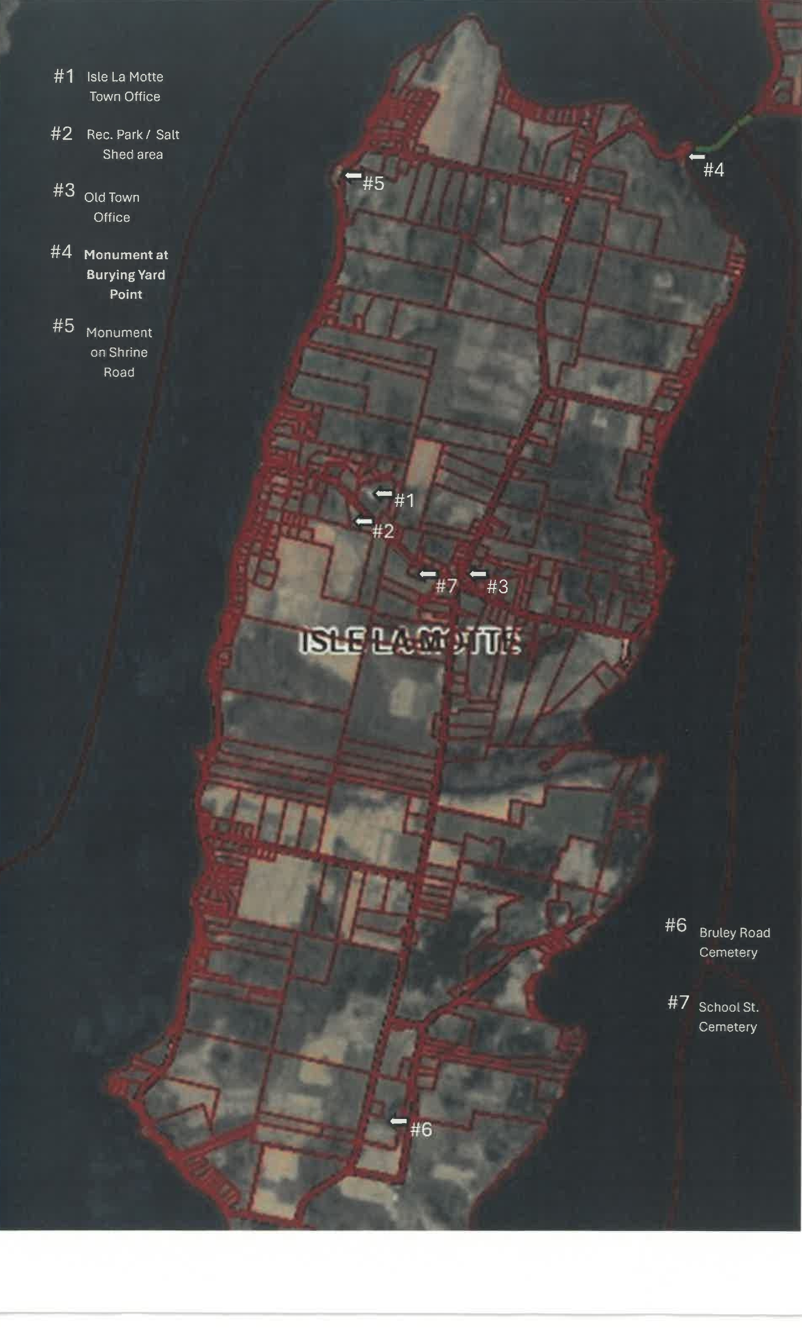

#5

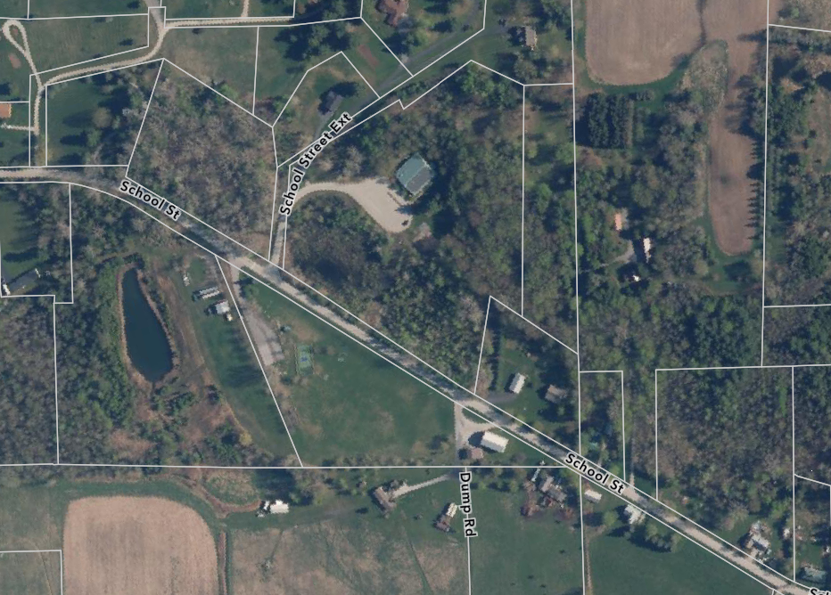

#1 Isle La Motte Town Offices

#2 Rec. Park & Salt Shed area

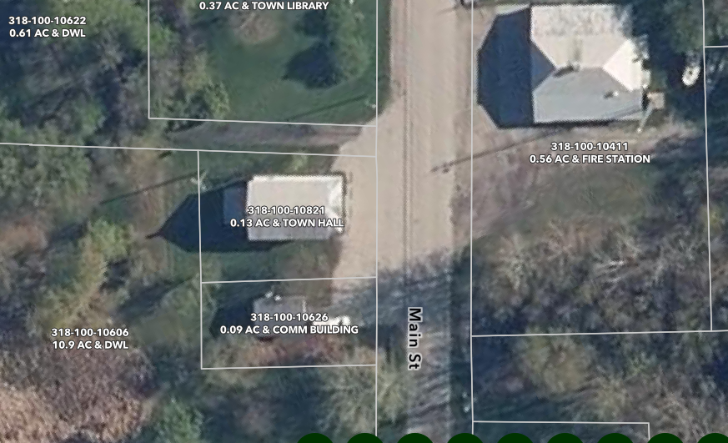

#3 Old Town Hall on Main Street

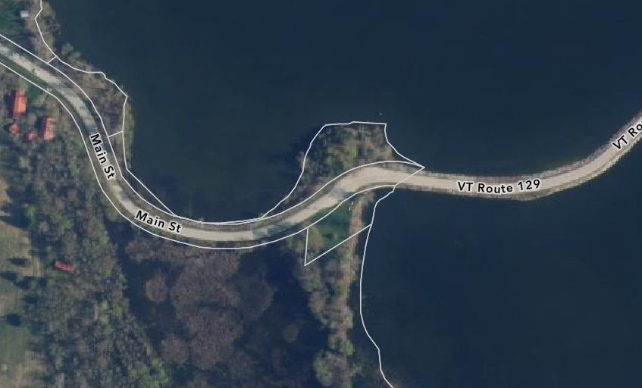

#4 Monument at Burying Yard Point

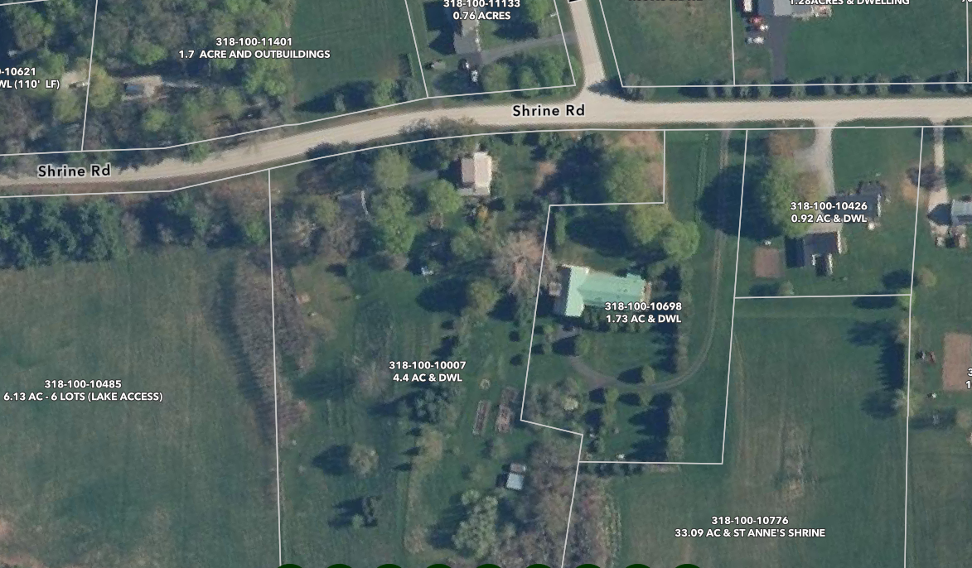

#5 Monument on Shrine Road

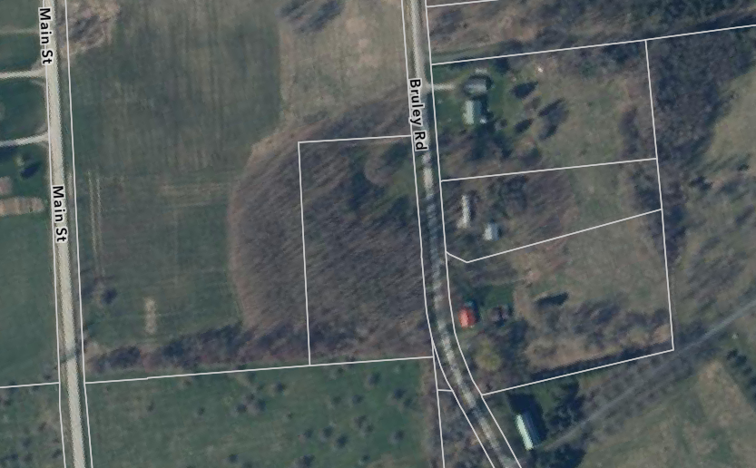

#6 Bruley Road Cemetery

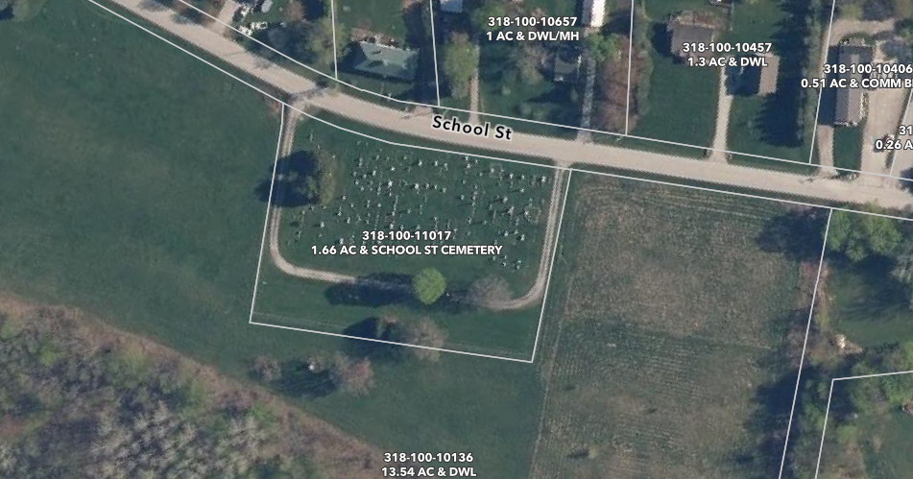

#7 School Street Cemetery

