Town of Isle La Motte
Select Board Meeting Agenda
Nov. 7, 2022
5:00 p.m. Town Office @ School

Agenda.

- Additions/deletions to agenda.
- Executive session if needed.
- Approval of minutes.
- Warrants for payroll & payables.
- Monthly budget and balance.
- Road commission report - bid limit discussion./Plowing bid on private roads?
- Meeting procedures.
- Animal Control appointment. / Update on English’s dogs.
- Sidewalk snow removal contract - ratify.
- Ratify transition audit.
- Audit bids FY22.
- Follow up on tree stands signs on Town owned property.
- Burn permit discussion/Fire warden.
- Sign copying policy.
- Emergency Management Performance Grant (EMPG).
- Errors & omissions.
- Possible tax sale.
- Rec. dept.
- Other business.
- Adjourn.

Select Board Meeting Minutes
07 November 2022 5:00 pm
Town Office at School
Present: Rusty Spaulding, Paul Zera (via zoom), Mary Catherine Graziano, Mary LaBrecque,
Deborah Spaulding, Deborah McMahon, Cary Sandvig, Cathy Tudhope, Barbara Callahan, Sylvia Jensen, Ann Jobin-Picard, Peter Brzozwy, Allen Hall,
Meeting called to order by Board Chair Rusty Spaulding at 5:00 pm
1 . Additions/Deletions to agenda : Sylvia Jensen asked about status of sale of lot. Mary
Catherine Graziano replied that there was a 30 day wait period. Chair Spaulding added that a sodium test on the well was completed and passed.
- Executive Session : Not needed.
- Approval of Minutes ;
21 Sept 2022 Special Elect Board Meeting: Motion to approve by Mary Catherine Graziano, second by Paul Zera. All in favor.
04 October 2022 Select Board Meeting: Motion to approve by Mary Catherine Graziano, second by Paul Zera, all in favor.
17 Oct 2022 Special Elect Board Meeting: Motion to approve by Mary Catherine Graziano, second by Paul Zera. All in favor.
Sylvia Jensen inquired as to when more Select Board Meeting minutes would be posted on the web site. Mary LaBrecque replied that she and the Clerk (Steve Mank) have been busy with election activities and taxes and will post more minutes as soon as they have time 4. Warrants and payables :
EFT transfer $388.64 10/15/2022. Ratification of Paul Zera's signature. Motion to ratify by Mary Catherine Graziano, second by Paul Zera. All in favor
Payroll : $1790.22 10/20/2022. Mary Catherine Graziano asked about former Clerks hours for this pay period. Mary LaBrecque replied that there was an oversight, the former Clerk had not been paid for her final week of working, and this was corrected a few days later. Ratification of Paul Zera's signature. Motion to ratify by Mary Catherine Graziano, second by Rusty Spaulding. All in favor.
Payroll : $1250.22 10/22/2022. Ratification of Paul Zera's signature. Motion to ratify by Mary
Catherine Graziano, second by Rusty Spaulding. All in favor
EFT $283.31 10/31/2022. Ratification of Paul Zera's signature. Motion to ratify by Mary
Catherine Graziano, second by Rusty Spaulding. All in favor
Payables : $69718.66. 10/31/2022. Ratification of Paul Zera's signature. Motion to ratify by Mary
- Monthly Budget & Balance Sheet : Not available due to a technical issue. This is only required to be reviewed quarterly.
- Discussion about private roads plowing, which will need to go out to bid. Road Commissioner Turner and Board Chair Spaulding discussed issues with Lockerby Lane, the end of Quarry Road and Light House Rd. In the past, John Beaulac had done this plowing in the past.
Discussion between Mary Catherine Graziano and Selby Turner about these roads. Sylvia
Jensen mentioned a survey of East Shore Rd as a reference. Mary Catherine Graziano agreed
to consult with Bethany Remmers from NWRPC. Road Commissioner Turner also wanted to ensure that the $10,000 bid limit would be on the March ballot.
The fog lines from the bridge up until the new paving on Main St will hopefully be completed by the time it snows. The cost is covered under the paving grant.
Road Commissioner Turner also commented on the new state requirements for culverts and who should bear the cost of these updates (property owner vs. town). He feels that for new construction should be borne by the homeowner, but upgrading to the state mandated 18' of existing culverts should be borne by the town. Mary Catherine Graziano pointed out that these are for hydrologically sensitive areas.
The work to be done in the next year has been identified.
- Meeting Procedures: Chair Spaulding commented that he does not like the addition where a meeting can be delayed due to one Board Member. Mary Catherine Graziano responded that this would not apply to regularly scheduled meetings, and only apply to meetings that were already being rescheduled, to ensure that the new day & time would work for all board members, unless the board member agrees to waive their right to be at the meeting. Will continue to discuss
- Animal Control Appointment : Deborah McMahon stated that she would like to apply for the animal control officer. She read the email that she had sent to the Select Board. Joyce Tuck shared that the library takes care of the cost of rabies shots for cats. Selby Turner commented that he felt that there could be numerous legal hurdles to clear. Sylvia Jensen commented that the Chittenden County Humane Society covers Grand Isle County and are very helpful. Motion to appoint Deb McMahon by Mary Catherine Graziano, second by Paul Zera. All in favor. Selby Turner inquired as to insurance coverage, it will be looked into. English's dogs: The owners of the dogs were sent an email, which they did not respond to. Deb McMahon will follow up. 9. Sidewalk snow removal contract : Motion to ratify by Mary Catherine Graziano, second by Paul Zera. All in favor.
10. Ratify transition audit: Motion to ratify by Mary Catherine Graziano, second by Paul Zera.
All in favor.
1 1 . Audit bids FY22 : The price went up to $9,000 from $7,500. Will discuss further next month.
- Follow up on tree stand signs on Town owned property : Chair Spaulding wondered where the signs should be placed, and how it will be policed. Mary Catherine Graziano replied that an adjacent property owner would remove stands in the Brothers property. Paul Zera countered that it is illegal for anyone to remove another's tree stand. He also stated that game wardens don't police Municipal property. Cary Sandvig suggested asking the Game Warden and Allen Hall mentioned that the Game Warden will remove tree stands that are unlabeled on public property. Chair Spaulding thought that placing signs at the entrance to public lands would be acceptable.
- Burn permit discussion/Fire Warden : Sean Peters has volunteered, he is a member of the fire department. Motion to appoint Sean Peters to Fire Warden by Mary Catherine Graziano, second by Paul Zera. All in favor.
- Copy Policy : Couldn't be located. Sylvia Jensen mentioned that she has a copy of it. She will email it to the town.
- Emergency Management Performance Grant (EMPG) : These are 50% match and ARPA money can be used. At one time the town had a few generators and they have all disappeared. Sylvia Jensen suggested investing in battery storage. Chair Spaulding countered that the generator needed would be large enough to not be able to disappear and that he doesn't feel the battery storage is yet sufficient to meet the needs of this size of buildings.
- Errors & Omissions : A four acre subdivision was inadvertently transferred in full to a new owner, however only one parcel should have been transferred. This ends up with a net gain of $21 ,200 in net assessment to the grand list. Motion to approve by Mary Catherine Graziano, second by Paul Zera. All in favor.
17.Possible tax sale : The tax sale, if held, will be 10 Jan. 2023. Delinquent Tax Collector Mary LaBrecque is proposing that the Select Board purchase the property. There is about $3500 owed in taxes. It was put up for tax sale in 2019, but the buyers backed out. Further discussion between Cathy Tudhope, Sylvia Jensen, Selby Turner, and Mary LaBrecque. It will be further discussed in December.
- Recreation Department : Ann Jobin Picard is planning on scheduling activities during the winter, maybe in February.
- Other Business : Another offer has been received on another lot at Sunset View. The offer was for $25,000 and the town paid $50,000. The possible salt issue has been resolved. Motion to reject bid made by Mary Catherine Graziano, second by Paul Zera. All in favor. Paul Zera asked about the minutes of the Trustees of Public Funds meeting of 06 Oct 2022. Cathy Tudhope replied that she had been unable to bring them to the office, and that she brought them today.
- Motion to adjourn at 6:30 by Mary Catherine Graziano, second by Paul Zera. All in favor.
Respectfully Submitted,
Mary LaBrecque

Rusty Spaulding

Paul Zera

Mary Catherine Graziano

Selectboard Meeting Sign in Sheet 51 k)oVZDZ
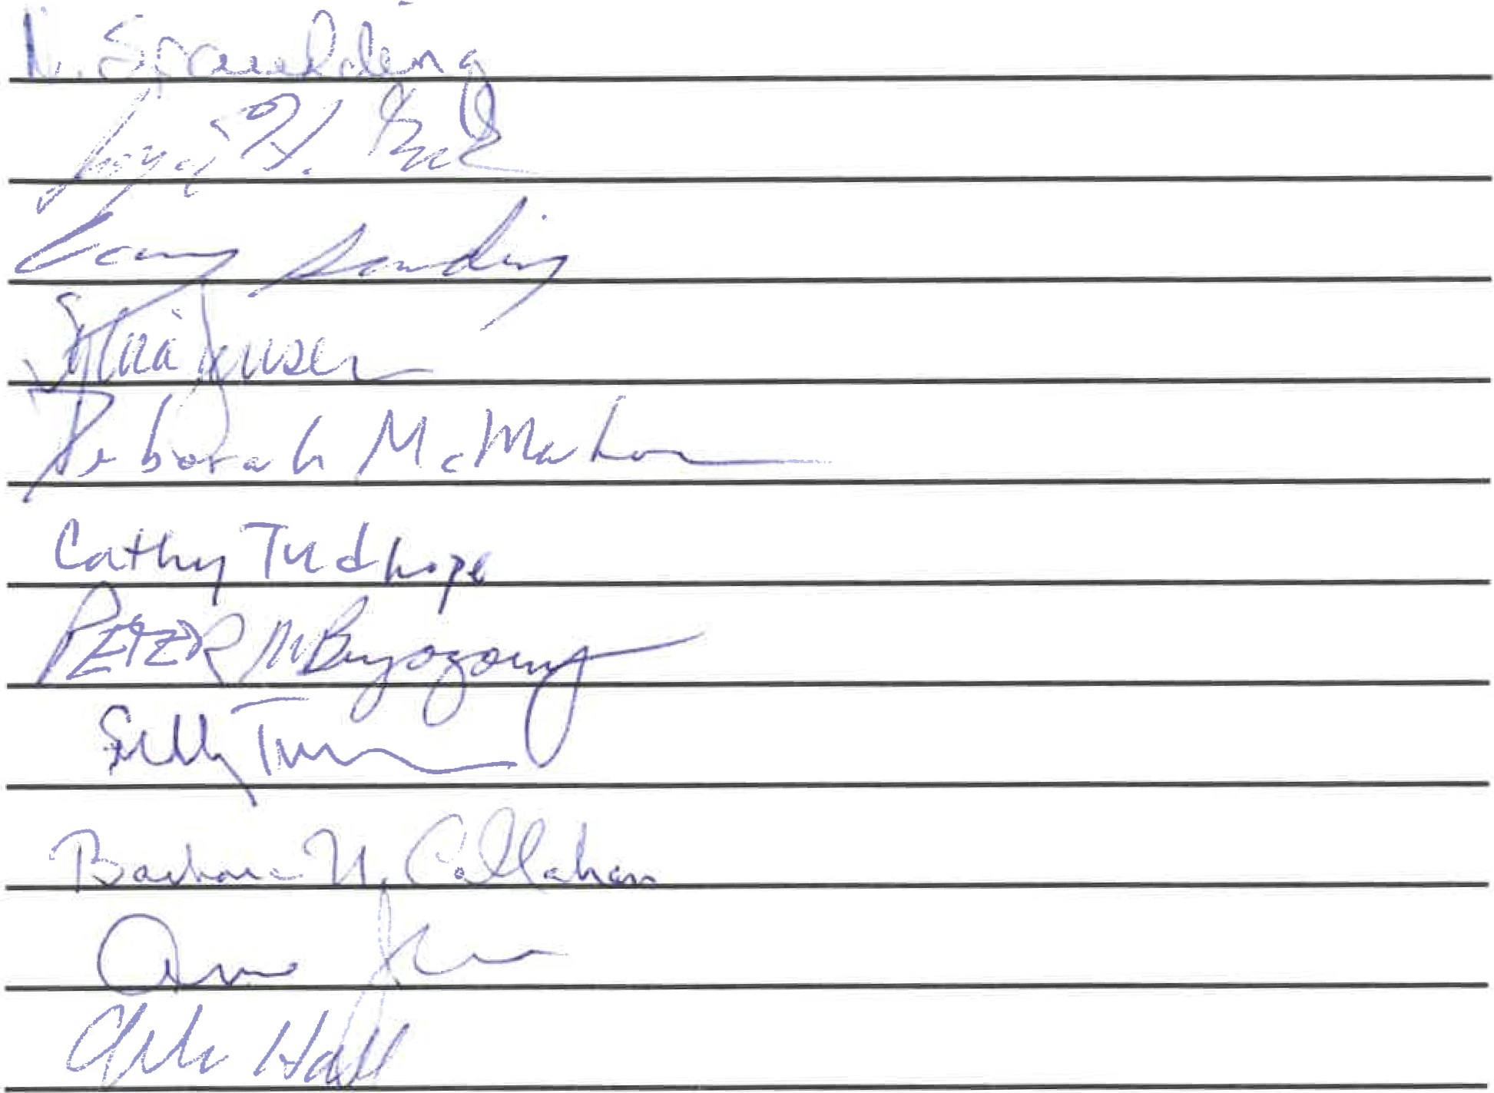

Gmail
Town Clerk <townofisIelamotte@gmaiJ.com>

Fwd: I'M ACO Proposal
1 message

Deborah Ann Martin <deborahannmcmahon@gmail.com> Mon, Nov 7, 2022 at 6:04 AM
To: Sarah Noble <townofislelamotte@gmail.com>
Here is my proposal for the Selectboard meeting tonight.
Sincerely,
Deborah McMahon
—— Forwarded message
From: Deborah Ann Martin <deborahannmcmahon@gmail.com>
Date: Sun, Nov 6, 2022, 9:13 PM
Subject: Il-M ACO
To: Deborah Ann Martin <deborahannmcmahon@gmail.com>
Dear Selectman/woman and citizens,
My name is Deborah McMahon and
I would like to be the Animal Control officer for Il-M.
- have skills in telecommunications, computer skills, marksmanship, animal care, (dogs, cats, horses, cows, birds) possess empathy, faimess, love and kindness to animals and their owners.
If appointed I ask you to consider allowing me to have the authority to deputize any adult qualified volunteer who comes forth and wishes to help or be a substitute volunteer not the ACO at zero cost to the town as this will ensure availability 24x7 in this endeavour and cite this authority in the ordinance.
- also ask the town to amend the animal ordinance to also have language as to the proper disposal and location determined where any wild roadkitl be property put on a town property and a
cruelty to animals clause, IN PARALLEL with state guidelines. ie: such as leaving an animal out in the cold or hot weather with no shelter, or water/food or adequate room to move and have a respectful life.
Cats currently in ILM do not need a license and I do NOT propose that but again a declaration from each owner would be nice to include in the ordinance and proffer a rabies shot, as they are more famous to roam if they sneak out, we could find the owner/s easier.
We could ask our citizens on election day to self declare or add a line to the tax bill to declare a cat/s or something like that.
It would need to be clear language to ensure our citizens that it is only for lost and found not to create revenue for a license, but if held at the kennel past one day (if built) would need to pay a nominal living/safety expense fee.
Then we can build a database so we do not have a situation again years ago on New Rd and Main St where dozens of cats were left behind in a locked house for months when the owner decided to move and the poor cats all died. As far as I know nothing was done to this person in this sad case.
I am innovative and self driven in all I do and believe I will do a fair, honest and thoughtful job.
If after one year assuming that I am still the ACO I propose that IL-M have there own facility instead of shipping animals to other towns or counties.
I believe this will save the town money and create less hardships and worry for the impounded animal owners involved.
I would be willing to build a new 22x22 building insulated heated/cooled facility
on my homestead at 427 Shrine Rd to kennel any domestic animal until the owner/s can be found for as long as I am fre Animal Control Officer. If one can not be found follow state rules.
It could also be a place for overflow for other Gl towns to use and Il-M Wilf levy a fee to those towns for kenneling, mileage, pickups and food etc. It could offset any expenses incurred.
I ask no money to build this structure only expenses like animal food, bedding, cleaning supplies, electric, insurance, security mileage, time to tend, telecommunications.
expect these costs would be minimal as we are not a big town nor do we have many animals causing real problems and if we get overflow fees from our neighboring towns it could help defer these costs.
The town will agree to have no monetary interest in my homestead at 427 Shrine Rd or this new facility on said property.
Town pays only the above expenses, and the ACO schedule already in place.
I will house the animals for in a clean, safe haven and charge the town no lease or rent only expenses and feed time.
The town receives the fees, and fines from the animal owners.
I accept the terms given to me about $500.00 and mileage, calls etc. If appointed.
While the selectboard town fathers/mothers determine if having an ILM housing venue on our own Island next year is a good idea in fellowship and an equitabFe one for our citizens and beloved animals f will utilize the rules in place at the present time and do more research with VT's other towns to achieve an appropriate building.
I am open to concrete criticisms and/or people becoming volunteers and ask anyone in town who has past knowledge and guidance, comments, ideas to make this plan viable call me, approach me, help the cause. Thank you.

Town of Isle La Motte Select Board Model Rules of Procedure
- PURPOSE.
The Select Board of the Town of Isle La Motte, is required by law to conduct its meetings in accordance with the Vermont Open Meeting Law. 1 V.S.A.310-314. Meetings of the Select Board of the Town of Isle La Motte must be open to the public at all times, except as provided in 1 V.S.A 313.
- APPLICATION.
This policy setäng forth rules of procedure shall apply to the Select Board of the Town of Isle La Motte, which is referred to below as "the body". These rules shall apply to all regular, special, and emergency meetings of the body.
- ORGANIZATION.
- The body shall annually elect a chair and a vice-chair. The chair of the body or, in the chair's absence, the vice-chair shall preside over all meetings.
- The Board Chair has the following responsibilities and duties:
  - The Board Chair shall preserve order in the meeting and shall regulate its proceedings by applying these rules and making determinations about all questions of order or procedure. (see item #7 under Section F "Public Participation")
  - The Board Chair is responsible for creating and determining the content of the agenda.
  - The Board Chair is delegated to be the contact person for the town attorney.
i. Town Attorney Communication Process:
    - The Board, as a whole, decides to contact the town attorney on a topic or question.
    - The Board Chair brings the item to the town attorney for the town attorney to respond in writing.
    - The Board Chair reports back to the board as a whole, in a timely manner, with the town attorney's written response.
- A majority of the members (two out of three) of the body shall constitute a quorum. If a quorum of the members of the body is not present at the meeting, no meeting shall take place.
- If a meeting date must be changed, or a special or emergency meeting must be held, then the new date and time must be a time that all members of the body are able to attend, unless a member voluntarily waives their right to participate in that meeting, and quorum is still able to be reached.
- No single member of the body shall have authority to represent or act on behalf of the body unless, by majority vote, the body has delegated such authority for a specific matter at a duly-noticed meeting and such delegation is recorded in the meeting minutes.
- Motions made by members of the body do require a second. The Board Chair of the body may make motions and may vote on all questions before the body. A motion will only pass if it receives the votes of a majority (two) of the total membership of the body.
- There is no limit to the number of times a member of the body may speak to a question. A member may speak or make a motion without being recognized by the Board Chair. Motions to close or limit debate will be entertained.
- Any member of the body may request a roll call vote. Pursuant to 1 V.S.A 312(a)(2), when one or more members attend a meeting electronically, a roll call vote is required for votes that are not unanimous.
- Meetings may be recessed to a time and place certain.
- These rules may be amended by a unanimous vote of the body, and must be readopted annually.
D. AGENDAS
- Each regular and special meeting of the body shall have an agenda, with time allotted for each item of business to be considered by the body. Those who wish to be added to the meeting agenda shall contact the Chair to request inclusion on the agenda. The chair shall determine the final content of the agenda.
  - The Chair will bring the agenda to the rest of the body no later than noon the Wednesday before scheduled meetings for review and any adjustments.
  - All requests of additions to agenda shall be in to the Chair no later than noon the Thursday before scheduled meetings.
  - The Chair shall allow reasonable additions to the agenda by other Select Board members.
- At least 48 hours prior to a regular meeting, and at least 24 hours prior to a special meeting, a meeting agenda shall be posted in or near the municipal office and at the following designated public places in the municipality. Isle La Motte Post Office, Old Town Office, and Town Website https://islelamotte.us), and posted on the ILM website calendar. The agenda must also be available to any person who requests such agenda prior to the meeting. 1 V.S.A. S 312(d).
- All business shall be conducted in the same order as it appears on the noticed agenda, except that any addition to or deletion from the noticed agenda must be made as the first act of business at the meeting. No additions to or deletions from the agenda shall be considered once the first act of business at the meeting has commenced. Any other adjustment to the noticed agenda, for example, changing the order of business, postponing or tabling actions, may be made by a unanimous vote of the body.
E. MEETINGS
- Regular meetings shall take place on the first Monday of the month at 5:00 p.m. at the Town Office.
- Special meetings shall be publicly announced at least 24 hours in advance by giving notice to all members of the body unless previously waived: to an editor, publisher or news director, or radio station serving the area: and to any person who has requested notice of such meetings. In addition, notices shall be posted in the municipal clerk's office and at the following designated places in the municipality: Isle La Motte Post Office, Old Town Office and Town Website (https://islelamotte.us)
- Emergency meetings may be held without public announcement, without posting of notices, and without 24-hour notice to members, provided some public notice thereof is given as soon as possible before any such meeting. Emergency meetings may be held only when necessary to respond to an unforeseen occurrence or condition requiring immediate attention by the public body.
- A member of the body may attend a regular, special, or emergency meeting by electronic or other means without being physically present at a designated meeting location, so long as the member identifies him or herself when the meeting is convened and is able to hear and be heard throughout the meeting. Whenever one or more members attend electronically, voting that is not unanimous must be done by roll call. If a quorum or more of the body attend a meeting (regular, special, or emergency) without being physically present at a designated meeting location, the agenda for the meeting shall designate at least one physical location where a member of the public can attend and participate in the meeting. At least one member of the body, or at least one staff or designee of the body, shall be physically present at each designated meeting location.
F. PUBLIC PARTICIPATION.
- All meetings of the body are meetings in the public, not of the public, Members of the public shall be afforded reasonable opportunity to express opinions about matters considered by the body, so long as order is maintained according to these rules.
- Meetings of the body are to be accessible remotely by zoom and phone. The information on how to connect to remote access to the body's meetings will be included in the agenda.
- At the beginning of discussion of each agenda item, but before any action is taken by the public body at each meeting, there may be five (5) minutes afforded for open public comment. After the public body has discussed the agenda item, there may be an additional two (2) minutes afforded for open public response. By majority vote, the body may increase the time for open public comment and its place on the agenda.
- Comment by the public or members of the body must be addressed to the Chair or to the body as a whole, and not to any individual member of the body or public.
- Members of the public must be acknowledged by the Chair before speaking.
- When acknowledged, members of the public must stand near the microphone, state their name for the record, before making their comment.
- If a member of the public has already spoken on a topic, he or she may not be recognized again until others have first been given the opportunity to comment.
- Order and decorum shall be observed by all persons present at the meeting. Neither members of the body, nor the members of the public, shall delay or interrupt the proceedings or the peace of the meeting or interrupt or disturb any member while speaking. Members of the body and members of the public are prohibited from making personal, impertinent, threatening, or profane remarks.
- Members of the body and members of the public shall obey the orders of the Chair or other presiding member. The Chair should adhere to the following process to restore order and decorum of a meeting but may bypass any or all when he or she determines in his or her sole discretion that deviation from the process is warranted.
  - Call the meeting to order and remind the members of the applicable rules of procedure.
  - Declare a recess or table the issue.
  - Adjourn the meeting until a time and date certain.
  - Order the constable to remove disorderly person(s) from the meeting.
ADOPTED:

Signatures Date

