Town of Isle La Motte
Select Board Meeting Agenda
July 5, 2022
5:00 p.m. Town Office @ School

Agenda.

- Additions/deletions to agenda
- Executive session if needed.
- Approval of minutes.
- Warrants for payroll & payables,
- Monthly budget and balance.
- Road commissioner report. – corners at bridge, culvert on Shrine Rd. Memorandum for Roads.
- Tent Waving fee.
- Mowing contract, ratify first cutting & go out for mowing contract.
- Mason’s use of school.
- Removal of late filed homestead penalty fee for Mary Elizabeth (Molly) Leddy & Porter Family Trust (Ann Porter).
- Set tax rate.
- Other business.
- Adjourn.

Town of Isle La Motte
Liquor Control Board Meeting
July 5, 2022
5:00 p.m. Town Office @ School

- Additions/deletions to agenda
- Approve Isle La Motte Vineyard outside consumption permit
- Other business

Town of Isle La Motte
Selectboard Meeting Minutes
July 5, 2022
5:00PM Town Office @ School

Members present: Rusty Spaulding & Mary Catherine Graziano.
Not present: Paul Zera
Other Present: Peter Brzozowy, Allen Hall, Joyce Tuck, Terrance Tuck, Sylvia Jensen, Alex Montagne, Selby Turner, Barbara Callahan, Anne Jobin-Picard, Stephen Zonies, Dane Bonn & Debbie Spaulding.

Meeting called to order at 5:00 by Chair, Rusty Spaulding.

- Additions/deletions to agenda
- Entrance to Town office/school and furniture in multip-purpose room.
- Recap for rec activities
- Executive session if needed- Not needed
- Approval of minutes
- Motion by Graziano to approve June 6, 2022 select board meeting minutes, 2nd by Spaulding– All in favor.
- Motion by Graziano to approve June 6, 2022 liquor control board meeting minutes, 2nd by Spaulding– All in favor.
- Motion by Graziano to approve June 6, 2022 special town meeting minutes, 2nd by Spaulding– All in favor.
- Warrants for payroll & payables
- Motion by Graziano to ratify 6/7/22 payroll, signed by Zera in the amount of $1,551.21, 2nd by Spaulding-- All in favor.
- Motion by Graziano to ratify 6/21/22 payroll, signed by Zera in the amount of $1,872.66, 2nd by Spauding-- All in favor.
- Motion by Graziano to approve 7/5/22 payroll in the amount of $1,751.54, 2nd by Spaulding-- All in favor.
- Motion by Graziano to ratify 6/20/22 EFT payable, signed by Zera in the amount of $594.61, 2nd by Spaulding-- All in favor.
- Motion by Spaulding to approve 7/5/22 EFT payable in the amount of $291.94, 2nd by Spaulding-- All in favor.
- Motion by Graziano to ratify 6/13/22 payable, signed by Zera in the amount of $25,061.93, 2nd by Spaulding-- All in favor. Most of this payable is County taxes.
- Motion by Graziano to approve 7/5/22 payable in the amount of $10,811.83, 2nd by Spaulding-- All in favor.
- Monthly budget and balance- No discussion.
- Road commissioner report- corners t bridge, culvert on Shrine Rd. Memorandum for roads
- Road commissioner Selby Turner had discussion; Culverts were ordered. He walked S-curves with Barbaa Callahan and it looks like the lilies planted there are trimmed around. John Yaratz is willing to mow in between lilies. The culvert on Shrine Rd. that was discussed at last months meeting needs more investigation.
- Spaulding had discussion; Selectman Spaulding stated there seems to be a problem with the McMahon culvert on Shrine Rd. He took his laser transit to take some elevation/grade readings. The readings were taken on 21 ft. each side of the culvert for a total reading of 62 ft. of ditch and culvert.
Spaulding stated if you stand on the road facing the ditch the high end on the left side of the culvert 21 ft. to the left of the culvert elevation reading is 6'11' 10 ft. to the right of that moving toward the culvert elevation is 7'1" 2 inches of grade which is more than enough in 10 ft. almost 2% grade. The next 10 ft. just before the culvert the owner of the property/driveway Deb McMahon stated at the previous monthly meeting that she had installed what appear to be 5 inch size stone in the ditch bottom just before the culvert to stop erosion, that reading is 6'7" which is 6 inches above the previous reading which is a problem for the flow of water. Directly presiding that is the bottom of the culvert which had a reading of 7'5" 4 inches below the ditch bottom 10 ft. up hill that is excellent grade.
The culvert is approximately 20 ft. long The down hill end of the culvert the reading is 7'6" that is 1 inch of grade for the 20 ft. that is on a little bit of trapped debris that is due to the larger stones, this is because on the down hill end the same size large stones where placed by the property owner making the culvert below grade on either end. The elevation on the large stones is 7'1" which makes the elevation at the end of the culvert equal to the first 10 ft. measurement on the upper end of the ditch. 10 ft. from the lower end of the culvert the elevation is 7'7" another 10 ft. down toward Sucker Brook the elevation is 8'3" . That means there is 1 ft. 4 inches of grade in 62 ft. of ditch which is excellent grade. The obvious problem is the property owners installed big stone on each of the culvert which has left the culvert sitting down in a bowl trapping water, salt and in the winter ice this has deteriorate the bottom third of the culvert and has rotten out some of the bottom. The culvert is still viable because it will be very hard for anyone one to change it due to the large bulk heads placed on either end by the property owner.
- Graziano had discussion; different treatments need to be done to control erosion depending on the grade of the culvert. If she does any work within the town ROW to remediate the problem, she should permit with the Town.
- Turner had discussion; culverts have been ordered, one is to replace near the old town office. There is a culvert on New Road that John Yaratz and myself are convince is rotten. It needs to be pulled and replaced.
- Joyce Tuck had discussion; the pot holes on Church Street have sunk since being filled.
- Turner had discussion; they will need more cold patch.

- Tent waiving fee
- Alex Montagne had discussion; made a formal request for th Town to waive the tent fee for ILMCO’s planned community barbecue.
- Spaulding had discussion; what needs to be done for insurance?
- Noble had discussion; when the tent is rented the Town is named as secondarily insured under the renters homeowners insurance. Being the rec park is Town property it already holds the insurance. The power will be turned on beforehand.
- Motion by Graziano to waive the tent rental fee, 2nd by Spaulding– All in favor.
- Spaulding had discussion; there was a tractor trailer truck bed parked for nearly a week at the rec park. The ordinance states ‘no overnight camping’, we should add a sign to state ‘no overnight parking’. This can be reviewed and we can discuss it at the next meeting.
- Spaulding had discussion; mowing has started, it missed going out for bid before the season started. We will put it out for bid shortly with is including one more mowing for this year and the remaining two years will have 2 mowing.
- More discussion was had on whether to change deadlines for mowing or to add a third cutting. This decision is tabled until the August meeting.
9. Mason’s use of school
- Spaulding had discussion; CIUUSD approved the masons use of the school for their annual member dinner.
- Motion by Graziano to approve the mason’s school use; 2nd by Spaulding– All in favor.
10. Removal of late filed homestead penalty fee for Mary Elizabeth (Molly) Leddy & Porter Family Trust (Anna Porter)
- Spaulding had discussion; these two parcels were assessed a late filed homestead penalty but did not receive the homestead rebate.
- Motion by Graziano to remove this penalty for both parcels, 2nd by Spaulding– All in favor.
11. Set Tax Rate
- Spaulding had discussion; Homestead education rate is $1.5407. Non-homestead education rate is $1.6237. Local agreement tax rate is .003459 and Town tax rate is .334540 (See attached).
- Motion by Graziano to approve setting tax rates; 2nd by Spaulding– All in favor.
12. Other business
- Sylvia Jensen had discussion; CIUUSD recently invited its staff and GISU staff to look at materials in the Isle La Motte School and to take those materials for their classrooms if they felt they could use them. The scissor tables in the multi-purpose room will be take to North Hero, in return CIUUSD maintenance will be replacing them with tables and chairs they already have. She has received complaints from people about the broken flower boxes outside; being the town is in charge of landscaping it is assumed it is town responsibility.
- Spaulding had discussion; the town is only responsible for mowing, the boxes are still CIUUSD property. Pictures have been sent to Michael Inners and will need further discussion between boards.
- Anne Jobin-Picard had discussion; the rec dept. had ten people attend line dancing. We are looking into tai chi/yoga/zumba. Island arts had a nice write up about activities in Isle La Motte.
- Graziano had discussion; if you get photos of these activities it would be great to post these on community forums to get more interest.
- Allen Hall had discussion; asked if we can make it so permanent tree stands can not be place on the ministers lots. They should be put up and taken down when leaving for the night. Peter Murray would be willing to monitor this property.
- Spaulding had discussion; the Town is behind this but can not police it.
- Sylvia Jensen had discussion; when are we placing the speed signs?
- Turner had discussion; the contractor we previously had backed out.
- Graziano had discussion; Bethany Remmers from Northwest Regional Planning Commission could be of help. They were supposed to sen out an intern to check the placement of these signs.
- Terry Tuck had discussion; at the last select board meeting Sylvia Jensen stated that the Masons were going to pay to move the Isle La Motte sign near the bridge. The Masons actually did not meet until the next day and were not presented with this request until after that board meeting. The Masons denied the proposal (see attached).
- Motion by Graziano to adjourn meeting at 6:05, 2nd by Spaulding– All in favor.

Respectfully submitted,
______________________
Sarah Noble Town Clerk

Approved on: _________________

________________________________
Rusty Spaulding

________________________________
Mary Catherine Graziano

________________________________
Paul Zera

司引22
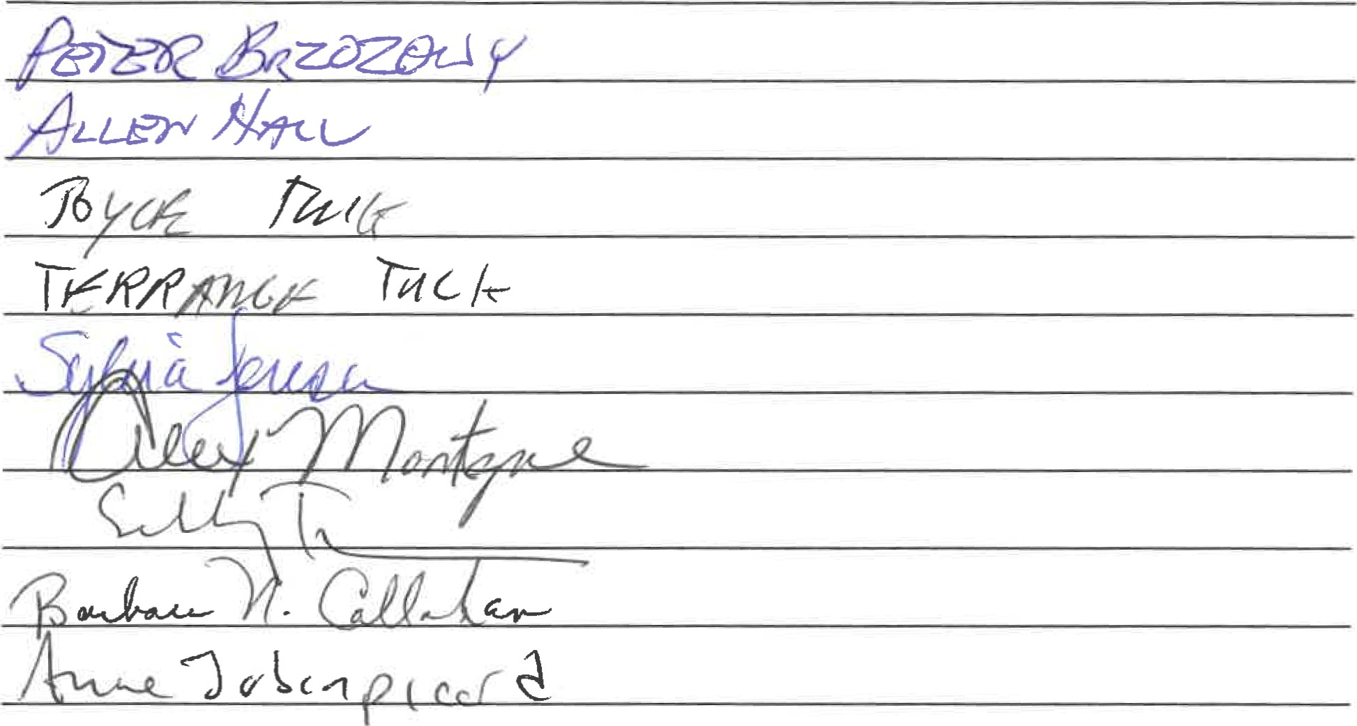

State of Vermont Agency ofAdministration
Department of Taxes
133 State Street
Montpelier, 05633-1401
Notice of Education Tax Rates for FY23
As per 32 V.S.A 5402(b)(1) the Education Property Tax Rates for your municipality have been calculated and set for FY23.
Town/City: Isle La Motte
2022 Reappraisal (blank unless reappraising): Common Level of Appraisal (CLA): 90.29%
Calculation Date: 06/28/22
Homestead Education Tax Rate to be Assessed: $1.5407
Your Homestead Education Tax Rate is calculatedfrom your city/town voter-approved per pupil education spending adjusted by the common level ofappraisal (CLA).
Nonhomestead Education Tax Rate to be Assessed: $1.6237
Nonhomestead property, previously called "non-residential, " is any property' which is not homestead property. Your city/town Nonhomestead Education Tax Rate is the statewide rate adjusted by the CLA.
Please refer to Education Property Tax Rates Department of Taxes (vennont.gov) for a summary table of Education Property Tax Rates for all municipalities and/or to review frequently asked questions about Education Property Taxes.
If you have questions about your Education Tax Rates, please call Property Valuation and Review (PVR) at the Vennont Department of Taxes at (802) 828-5860 or email tax.pvr@vermont.gov.
/—.VERMONT

https://tax.vermont.gov
Town & local agreement tax rates
Budget passed - $418,812.00
Voted articles- 12 000.00
TOTAL - $ 430,892.00
430,892.00 divided by grand list 1,288,013.00 = 334540 Town tax rate
Local agreement - Fire Dept. & Masons = $227,000.00 x 1% = 2270.00 x non res. Tax rate 1.6237 = 3685.79
Vet exempts -50,000.00 x = 500.00 x 1.5407 res tax rate = 770.35
Total 4456.14
4456.14 divided by 1,288,013.00 = .003459 local agreement
Res tax rate is 1.5407
Non Res rate is 1.6237
My name is Terrance Tuck and I have been a Mason in the Isle La Motte lodge for a number of years. At present I am the master of the lodge. It has come to our attention that at the last select board meeting that Ms. Jensen stated that the Masons were going to pay to move the Isle La Motte sign. Ms. Jensen had not presented a proposal regarding the sign to the Masons at that time, The proposal she final presented is out of the Question. There is not enough room for what she has proposed and as it is a cemetary you can't just dig it up. Also you may have to get permission to do anything from the legislature. The cost of her proposal (6,000.00) Is also out of the question. Thank You

