Town of Isle La Motte
Select board Meeting
Jan. 3, 2022
5:00 p.m. @ School

Agenda
- Additions to agenda.
- Appointment of select board member
- Executive session if needed.
- Old Town office update.
- Approve minutes.
- copy price verification
- Warrants for payroll & payable.
- Monthly budget and balance sheet/ Budget discussion.
- Road commissioner report.
- Snow removal for sidewalks.
- Other business
- Adjourn.

 | Current Yr Pd: 9 - Budget Status Report
 | Account | Budget |  | Actual % of Budget |  |  |  | 2022 BUDGET
 | 01-010.01 Recording Fees | 8000 8856 |  |  |  | 111 |  | 8000
 | 01-010.02 Copy\Fax Fees 1400 |  |  | 1952 |  | 139 1500
 | 01-010.03 Title Search | 200 |  | 271 |  | 136 |  | 200
 | 01-010.04 Del. Tax Coll. Commission | 5000 |  | 9462 |  | 189 |  | 5000
 | 01-010.08 Delinquent Tax Interest | 5000 |  | 9692 |  | 194 |  | 8000
 | 01-010.11 Land rec. Restoration Res | 3220 |  |  |  | 100 |  | 3220
 | 01-010.12 Interest Income 500 |  |  | 4183 |  | 32 200
 | 01-010.14 Licenses | 1000 922 |  |  |  | 92 |  | 1000
01-010.16 Rent of Town Lands
01-010.17 Town Land Sale
 | 01-010.18 St Edmund Society Donatio | 1000 |  | 1000 |  | 100 |  | 1000
 | 01-010.22 State Hold Harmless Pymt. 10420 |  |  | 8979 |  | 86 8900
 | 01-010.24 ARPA FUNDS |  |  | 74433
 | 01-010.27 PILOT | 2500 |  | 2491 |  | *100 |  | 2500
 | 01-010.28 Items for sale
 | 01-010.29 Permits | 250 280 |  |  |  | 112 |  | 250
 | 01-010.30 Civil Fines  01-010.32 Payment from Escrow | 100 |  | 380 380 300
 | 01-010.33 Reimbursements
 | 01-010.98 Non-tax Gen. Rev. Surplus
 | 01-010.99 Misc Revenues
 | TOTAL GEN FUND NON-TAX REVENUE | 35370 |  | 122122 |  | 40070
 | 01-1 ADMINISTRATION
 | 01-101.00 Insurance | 878 -2
 | 01-102.00 County Taxes | 40060 |  | 41847 |  | 104 41847
 | 01-104.00 Legal Fees 4000 4756 |  |  |  |  | 119 |  | 4000
 | 01-105.00 Voting Supplie'b | 200 |  |  |  | 0 |  | 100
 | 01-105.05 Dues  01-106.00 BCA/EIection | 1600 1684 105 |  |  |  |  |  | 1600
 |  | 500 220 |  |  |  | 44 |  | 400
 | 01-107.00 Del Tax Commissions%- | 2000 |  | 5241 |  | 262 5000
 | 01-107.01 Tax abatement- principal 300 |  |  | 295 |  | 98 |  | 300
 | 01-107.02 Tax abatement- interest 10  68 |  |  |  |  | 683 |  | 70
01-107.03 Tax abatement- penalty
25 23 93 25
 | 01-107.04 Tax abatement- other
 | 01-108.00 Land Record restoration | 500 |  | 1560 312 1500
 | 01-109.00 Telephone\Fax\lnternet | 2000 |  | 1969 98 |  |  |  | 2000
 | 01-110.00 Salary Clerk | 17640 |  | 17640 |  | 100 |  | 18628
 | 01-110.05 Office Assistant | 14144 |  | 13729 97 14144
 | 01-111.00 Other Wages & Salaries
 | 01-111.01 Town Auditor Salaries
01-111.03 Selectboard Salaries |  |  | 3000 |  | 2764 |  | 92 |  | 3000
01-111.04 Cemetery Commissioner Pay |  |  | 990 |  | 990 |  | 100 |  | 990
01-111.05 FICA/MEDI Employer  01-111.06 Town Handyman Wages |  |  |  |  | 5200 |  | 106 |  | 5000
01-111.07 Clerk of the Board wages |  |  | 3100 |  | 3300 |  | 106 |  | 3000
01-112.00 Salary Treasurer |  |  | 15640 |  | 15640 |  | 100 |  | 16516
01-113.00 Officers Expenses/MiIeage |  |  | 900 |  | 998 |  | 111 |  | 900
01-114.00 Supplies\Postage |  |  | 4000 |  | 4275 |  | 107 |  | 4000
01-115.00 Equip. Rental\Purchase |  |  | 2900 |  | 2829 |  | 98 |  | 2900
01-116.00 Computer\Maintenance |  |  | 6000 |  | 6048 |  | 101 |  | 6000
01-117.00 Town Report |  |  | 600 |  | 585 |  | 97 |  | 600
01-118.00 Animal Control/Constable |  |  | 500 |  | 190 |  | 38 |  | 500
01-120.00 Bank Service Charges |  |  | 150 |  | 176 |  | 117 |  | 150
01-120.01 Interest Expenditure |  |  | 898 |  | 898 |  | 100 |  | 898
01-121.00 Health\Dental |  |  | 3800 |  | 3800 |  | 100 |  | 3800
01-122.00 Retirement Account |  |  | 1625 |  | 1764 |  | 109 |  | 1764
01-123.00 Website |  |  | 495 |  | 495 |  | 100 |  | 495
01-124.00 Advertising |  |  | 750 |  | 792 |  | 106 |  | 750
01-125.00 Training  01-125.01 Training Wages |  |  | 200 |  | 28 |  | 14 |  | 200
01-126.00 Unemployment  01-127.01 Deficit Liquidation  01-128.00 Supplies for resale  01-129.00 Unreal. loss land investm |  |  | 200 |  |  |  |  |  | 200
TOTAL ADMIMISTRATION  01-2 SOLID WASTE  01-201.00 MohitoFing\Lab Charges |  |  | 134505 |  | *139801 |  |  |  | 141277
01-203.00 Northwest Solid Waste Dis  01-204.00 Meeting Mileage Reimb.y  01-205.00 Special Trash |  |  | 483  400 |  | 483 |  | 100| |  | 483
TOTAL SOLID  01-3 TOWN HALL |  |  | 883 |  | 483 |  |  |  | 483
01-301.00 Custodial\Trash Removal' |  |  | 900 |  | 372 |  | 41 |  | 900
01-302.00 Fuel |  |  | 1050 |  | 1554 |  | 148 |  | 500
01-303.00 Electricity  01-304.00 Renovations |  |  | 900 |  | 1548 |  | 172 |  | 900
01-305.00 Repairs\Maintenance |  |  | 1000 |  | 523 |  | 52 |  | 500
01-306.00 Supplies |  |  | 650 |  | 692 |  | 106 |  | 650
TOTAL TOWN HALL |  |  | 4500 |  | 4688 |  |  |  | 3450
01-4 APPROPRIATIONS
01-401.00 Cemeteries

01-403.00 Fire\Rescue | 40000 40000 |  | 100 | 40000
01-404.00 Visiting Nurse Associatio | 2100 2100 |  | 100 2500
01-406.00 Champlain Valley Agency o
01-407.00 Vt. Independent Living 295 295 |  |  | 100 295
01-410.00 LCI Economic Dev. corp. | 500 | 500 100 |  | 500
01-411.00 American Red Cross | 350 350 |  | 100 | 350
01-412.00 Northwest Regional Planni | 537 | 537 100 |  | 547
01-414.00 Grand Isle Court Diversio | 250 1000 |  | 400
01-415.00 Vt. Green-Up | 50 | 50 100 50
01-416.00 N VT Resource Cons & Dev
01-418.00 N W Counseling & Support |  |  | 700
01-419.00 Voices Against Violence | 990 | R 990 | 100 | 1000
01-420.00 VT Trails & Greenways
01-421.00 NW Unit Special Investiga | 1500 | 100  1500 |  | 1500
01-422.00 Grand Isle co. Mentoring
01-425.00 Town Use of School
 | 14500 | 14500 100 14500
01-426.00 Vermont Adult Learning
01-431.00 Island Arts | 1000 | 1000 100 1500
01-432.00 VT CENTER INDEP LIVING
01-434.00 AGE WELL
 | 700 | 700 | 100 1000
01-435.00 VT Family Network | 250 | 250 | 100 | 250
TOTAL APPROPRIATIONS | 64122 | 64872 |  | 65792
01-7 OTHER
01-702.00 Land Purchase
01-703.00 Rec Site/Mowing% | 4000 | 4689 117 |  | 5000
01-704.00 G.I.% Sheriff Contract | 34320 | 34320 | 100 | 36634
01-705.00 ChariÖlain Statue
01-706.00 Town bf. Facility
01-707.00 Loan Anticipation Note | 0
01-709.01 Grandparent Program Hot L
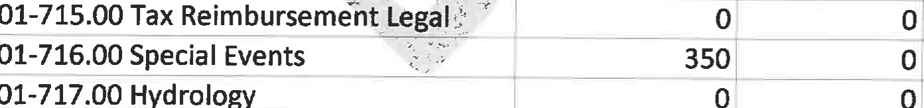 |  |  |  | 350
01-717.00 Hydrology
01-717.01 LaBombard Ditch & Dump ca
01-717.02 Four Corners Drainage
01-718.00 Town lots | 600 600 100 600
TOTAL OTHER | 39270 | 39609 |  | 42584
01-8 SERVICES |  |  | 100 | 4000
01-801.00 Cemeteries | 4000
01-802.00 Library

01-803.00 Alburgh/Fire Rescue |  | 6500 |  | 6500 |  |  | 100 |  | 6500
01-804.00 VT State Police  01-999.99 Transfer to other funds |  | 50 |  | 50 |  |  | 100 |  | 50
TOTAL SERVICES  02-0 RECREATION REVENUE |  | 10550 |  | 10550 |  |  |  |  | 10550
02-010.01 Rec Dept Events Revenue |  | 500 |  | 225 |  |  | 45 |  | 3500
02-010.02 Rec Dept Grants & Donatio |  | 2100 |  | 1000 |  |  | 48
TOTAL REC REVENUE  02-1 RECREATION EXPENSE  02-101.00 Recreation Events Expense |  | 2600 |  | 1225 |  |  |  |  | 3500
02-101.03 Rec Park Upgrades & Maint  02-101.05 Recreation Handy Man  02-102.00 Rec Administrative Supply |  | 2100 |  | 690 |  |  | 33 |  | 3500
TOTAL REC EXPENSE  03-0 HIGHWAY REVENUE |  | 2600 |  | 690 |  |  |  |  | 3500
03-010.00 State Aid to Highways  03-010.01 VT Highway Grants  03-010.02 FEMA  03-010.03 VT Structures Grant  03-010.04 Bank loan revenue  03-010.98 Highway Budget Surplus  03-011.00 Federal Highway Grant |  | 48000 |  | 53025 |  |  | 110 |  | 48000  25000
03-012.00 HIGHWAY RESERVE  03-999.99 Transfer from General Fun |  |  |  | o |  |  |  |  | 17000
TOTAL HIGHWAY REVENUE  03-5 WINTER ROADS |  | 48000 |  | 53025 |  |  |  |  | 90000
03-501.00 Snow removal |  | 135000 |  | 157500 |  |  | 117 |  | 180000
03-502.00 Salt and sand  03-503.00 Drainage  03-504.00 Salt Shed |  | 38000  500 |  | 16051 |  |  | 42 |  | 30000
03-505.00 Interest on Loan |  | 1891 |  | 1033 |  |  | 55 |  | 1100
03-506.00 Loan Re-payment  03-6 SUMMER ROADS |  | 9000 |  | 9000 |  |  | 100 |  | 9000
03-601.00 Paving/Blacktop |  | 10000 |  | 400 |  |  | 4 |  | 5000
03-602.00 Gravel and Stone |  | 12000 |  | 5521 |  |  | 46 |  | 7000
 | 03-603.00 Pot Hole Repair |  | 1500 |  | 1407 |  |  | 94 |  | 1500
 | 03-604.00 Ditching & Culverts |  | 7000 |  | 630 |  |  | 9 |  | 4000
 | 03-605.00 Erosion Control |  | 200 |  | O
 | 03-606.00 Mowing Roadsides |  | 8000 |  | 7250 |  |  | 91 |  | 8000
 | 03-607.00 Grading/ChIoride  03-608.00 Equipment Rental |  | 8000 |  | 3005 |  |  | 38 |  | 6000
 | 03-609.00 Highways Markers  03-610.00 Storm Damage Repairs |  | 7000  500 |  | 13590 |  |  | 194 |  | 7000
 | 03-611.00 Grant Projects 03-611.01 East Shore Road  03-611.02 Stormwater  03-611.03 Quarry Road  03-611.04 Loon's Landing  03-611.06 Lighthouse Point Rd. |  | 17000 |  |  |  |  |  |  | 34000 o
 | 03-612.00 Tree/Brush Removal |  | 3000 |  | 1600 |  |  | 53 |  | 5000
 | 03-613.00 Engineering |  | soo |  |  | eve'. |  |  |  | 500
 | 03-614.00 Road Commissioner wages |  | 4000 |  | 4000 |  |  | 100 |  | 4000
 | 03-615.00 Misc Road Exp/Street Ligh |  | 2300 |  | 964 |  |  | 42 |  | 1200
 | 03-616.00 Misc Road Labor |  | 1000 |  | 1865 |  |  | 187 |  | 2000
 | 03-617.00 REI EXPENSE |  |  |  | 740 |  |  | 100 |  | 740
 | TOTAL HIGHWAY EXPENSE  04-0 LISTER REVENUE |  | 266391 |  | 224556 |  |  |  |  | 306040
 | 04-010.25 Parcel Maintenance Revenu  04-010.26 Lister Education Revenue  04-999.99 TRANSFER FROM GENERAL FU |  | 8630 |  | 8379 |  |  | 97 |  | 8400
 | TOTAL LISTER REVENUE  04-1 LISTER EXPENSE |  | 8630 |  | 8379 |  |  |  |  | 8400
 | 04-101.00 Lister Postage & Supplies |  | 200 |  | 98 |  |  | 49 |  | 100
 | 04-102.00 Computer/ Software/lT , |  | 1000 |  | 1546 |  |  | 155 |  | 1500
 | 04-103.00 Tax Mapping |  | 2000 |  | 1475 |  |  | 74 |  | 2000
 | 04-104.00 Lister Mileage |  | 200 |  |  |  |  | 0 |  | 200
 | 04-105.00 Lister Media Warnings & |  | 200 |  | 320 |  |  | 160 |  | 300
 | 04-106.00 Lister Training |  | 400 |  |  |  |  |  |  | 400
 | 04-111.02 Board of Lister Wages 04-119.00 Reappraisal & Maintenance  04-120.00 APPRAISAL  04-120.01 REAPPRAISAL WAGES |  | 2000 |  | 2636 |  |  | 132 |  | 2600
 | TOTAL LISTER EXPENSE |  | 6000 |  | 6076 |  |  |  |  | 7100
05-01 AUDIT FUND REVENUE
05-010.00 Audit Fund revenue
05-999.99 Transfer from General Fun
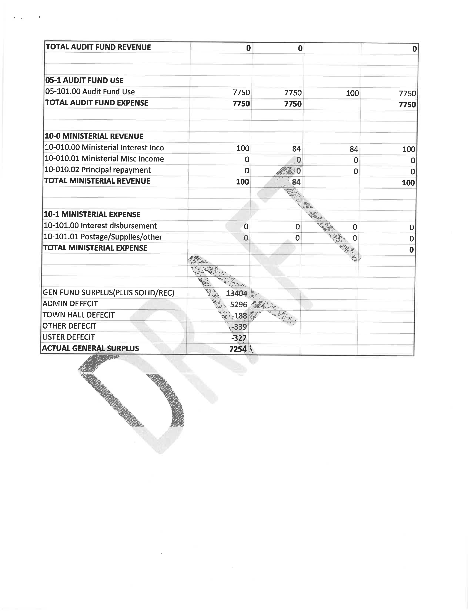

TOWN OF ISLE LAMOTTE
P.O. BOX 250
ISLE LA MOTTE, VERMONT 05463
(Vzzmon±'s (..DCÆEåÉ SEÉdzmznÉ
Snow Removal Contract for Front Entrance
And Sidewalk for Multipurpose Room
Specifications:
Removal of 2 or more inches of snow for front entrance and sidewalk to multipurpose room.
Front entrance Monday through Thursday by 9:00 a.m.
Multipurpose room minimum of first Monday of every month by 4:00 p.m.

Town of Isle La Motte will provide the salt.
Rate $18.00 per hour for labor.
$18.00 per hour for tractor and snowblower.
Invoice must contain action taken and time.
Rusty Spaulding | Keith Bonneville
Paul Zera Date
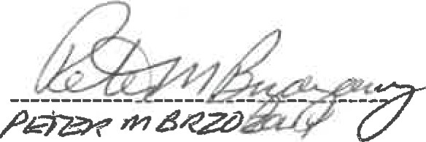
Date

