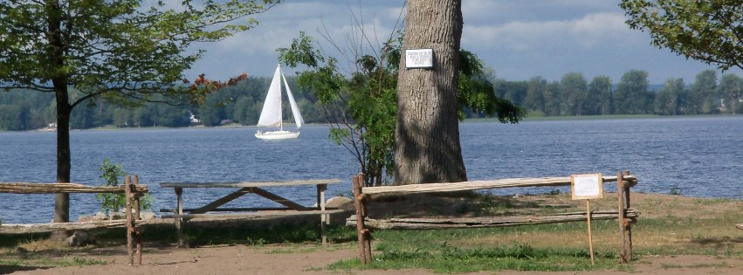
Isle La MOTTE 5 K RACE/ ½ MILE FUN RUN AT ST. ANNE’S SHRINE
JULY 14, 2018

USATF CERTIFIED COURSE
Beginning and ending at the historic site of the St. Anne’s Shrine. Extremely fast and flat. Run along West Shore of Lake Champlain. We are proud that half of this year’s net proceeds will benefit the Hope Lodge of Burlington and the other half the Isle La Motte Recreation Department. The Hope Lodge offers free temporary accommodations for cancer patients and caregivers. It allows the patient to focus on the most important thing, getting well.
Follow us on Facebook at Isle la Motte 5k Race

REGISTRATION
This year registration is being coordinated by RunVermont.org
Online registration link is https://runsignup.com/ilm2018 Over 18 years of age -$25 14 years thru age 18-$15, Under age 14-$5 Including Fun Run

Active military and veterans-$15

Tech shirts will be provided to the first 100 entrants and additionally all kids in the1/2 mile fun run will receive a shirt. Prizes to the top male and female finishers. There will be prizes for most age categories and random prize drawings for all to win. Prizes for all half mile finishers. Food/water for all participants.

SCHEDULE
7:15 AM check-in and registration
8:15 AM ½ Mile Youth Fun Run (12 yrs and younger)
8:30 AM 5 K Run
Awards presentation
For information call 928-3434 or http://islelamotte.us/?pageid=28

